**Distance measurement project**

**Arduino Human Following Robot**

**By**

**Thitinat Boonmapa 622115009**

**BACHELOR OF SCIENCE**

**SOFTWARE ENGINEERING PROGRAM**

**COLLEGE OF ARTS MEDIA AND TECHNOLOGY**

**CHIANG MAI UNIVERSITY**

**Professor. Phudinan Singkhamfu**

# Chapter1: Introduction and Background

Nowadays, human tracking robots have been continuously reviewed and developed over the years until now. Due to its many uses in daily life and production. Robots that work with humans require a variety of strategies. Including robot control algorithms identifying human goals and avoiding obstacles Ultrasonic sensors, infrared sensors, voice recognition sensors, laser distance sensors, dual camera chargers (CCDs) and other human-tracked robotic processes can distinguish between general-purpose robots and local people.

The robot must be able to detect and track humans. A robot that can detect and track humans or obstacles within a certain range is called a robot. 'Human tracking robot'. Robots are used to change people's lives and make people's lives more comfortable. For example, a robot carries things and follows humans without remote control, A robot that can be used in hospitals can deliver medicines to patients more accurately and quickly. Robots that follow humans have a lot to do with tasks such as trolleys, hospital structures, small carts with cars, and so on.

In this project, methods for determining human positions using ultrasonic sensors and infrared sensors are provided in this study. This is an important step in the human evolution of robots. In action, The robot is equipped with ultrasonic sensors in person and uses infrared sensors as well by controlling through development motor control shield and Arduino Board.

# Chapter2: Components and Supplies

1. 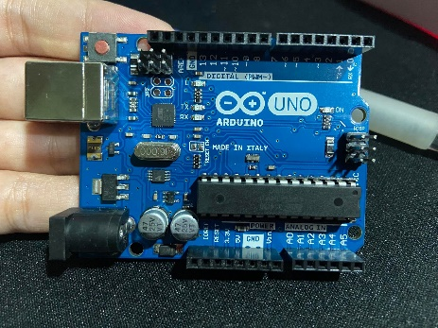Arduino UNO

Arduino Uno is a microcontroller board based on the ATmega328P (datasheet). It has 14 digital input/output pins (of which 6 can be used as PWM outputs), 6 analog inputs, a 16 MHz ceramic resonator (CSTCE16M0V53-R0), a USB connection, a power jack, an ICSP header and a reset button.

1. Geared DC Motor

3 -12VDC Gear motor with a right-angle drive gearbox offering 180:1 reduction, making it perfect for drive-train use in small to mid-sized robotics and R/C projects.

1. Development Board, Motor Control Shield

The OSEPP Motor and Servo Shield can plug directly onto the Arduino and Arduino compatible boards. It supports up to 2 servo motors and 4 bi-directional DC motors, or 2 servo motor and 2 stepper motors. Servo header and terminal blocks are provided for easy connection to motor. The servo power supply and motor power supply can be configured to source from an individual terminal block or from the Arduino board providing flexibility to your project. Mate with Arduino and Arduino compatible boards.